Brian Engel

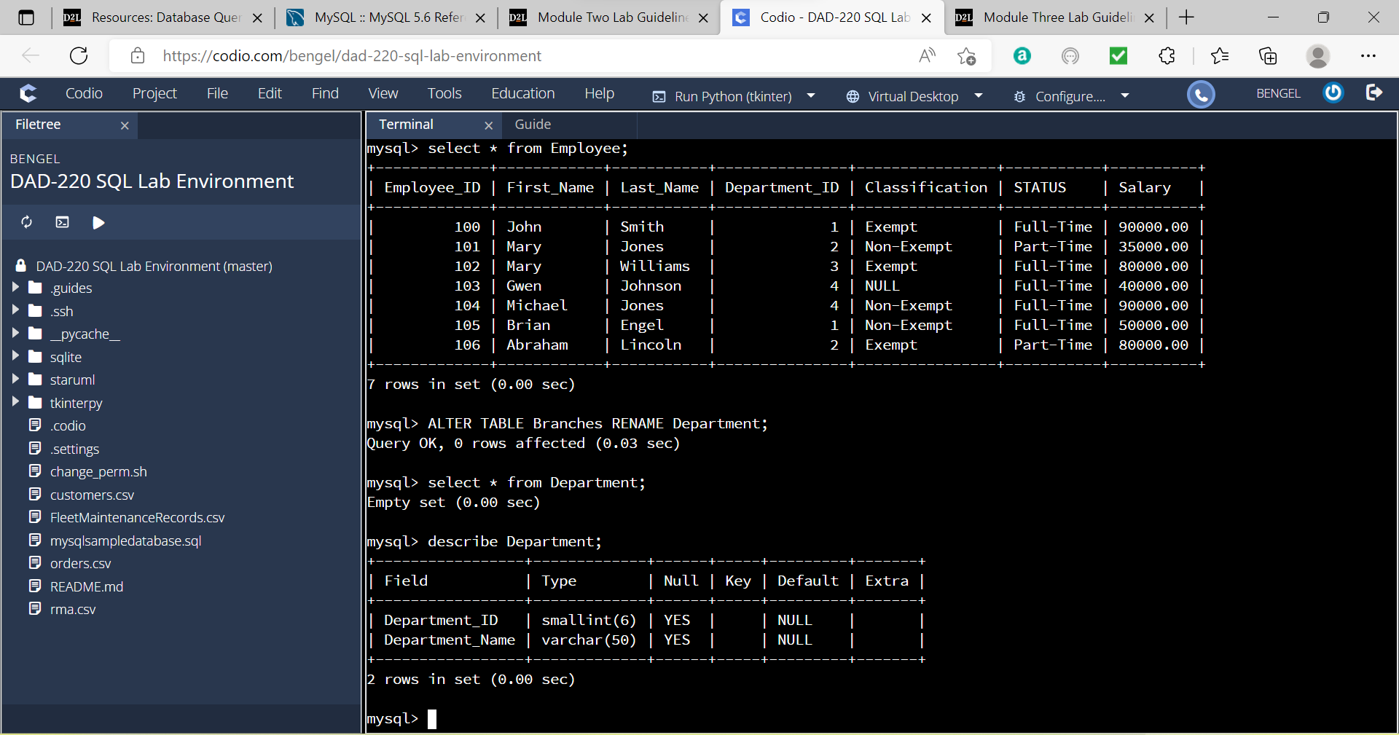

1. Update the name of the Branches table to Departments

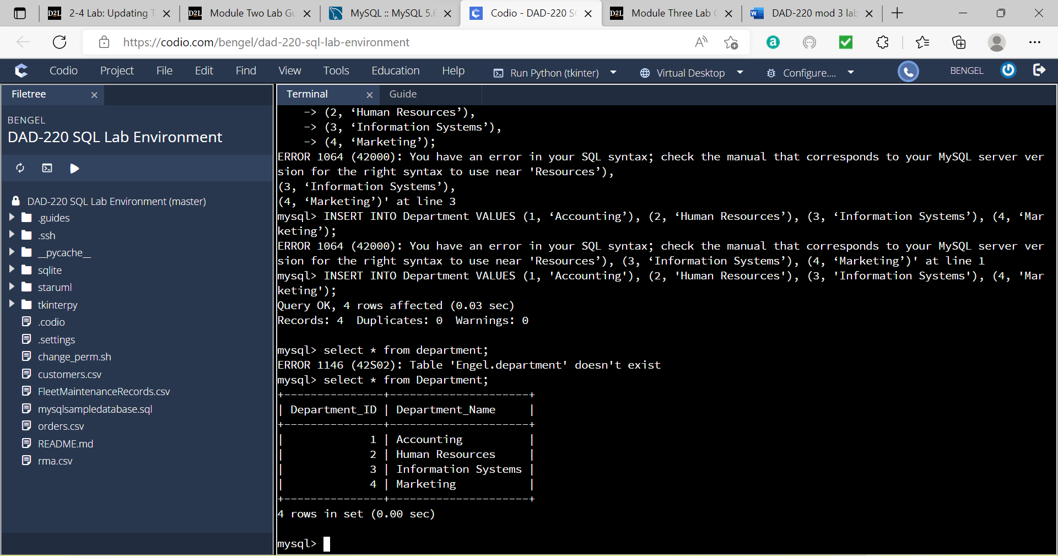

1. Insert fields into the Department table

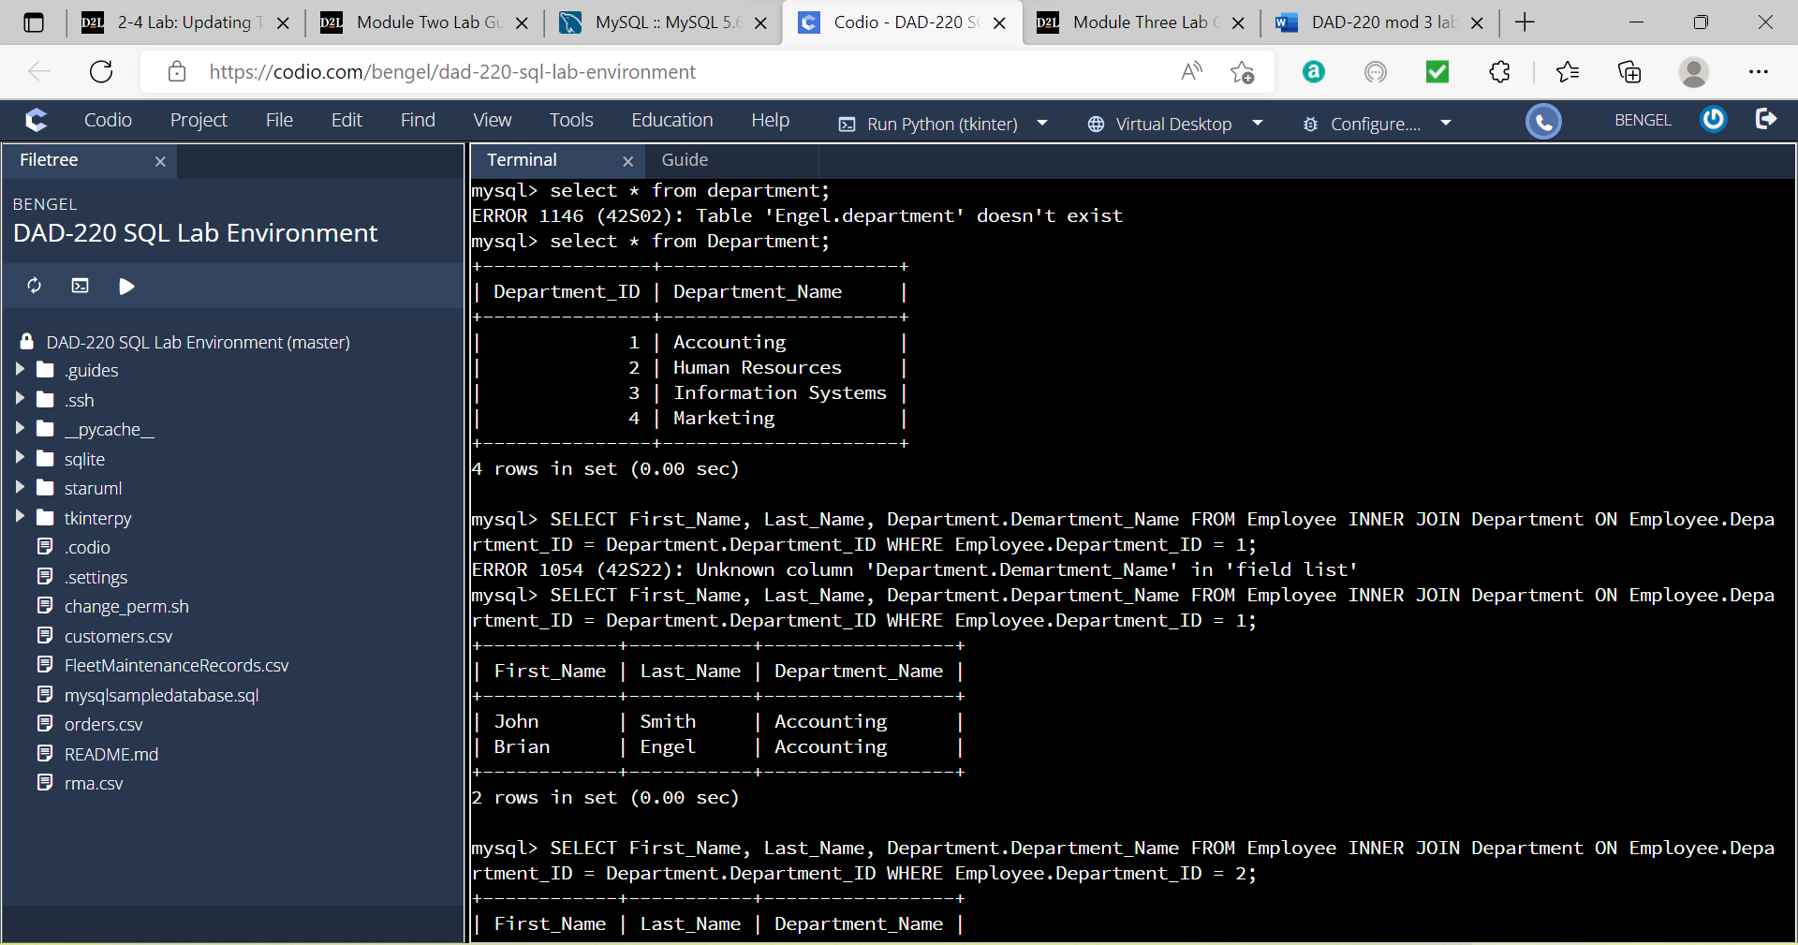

1. Preform joins between the Department and Employee tables and show results

A. Department 1 - Accounting

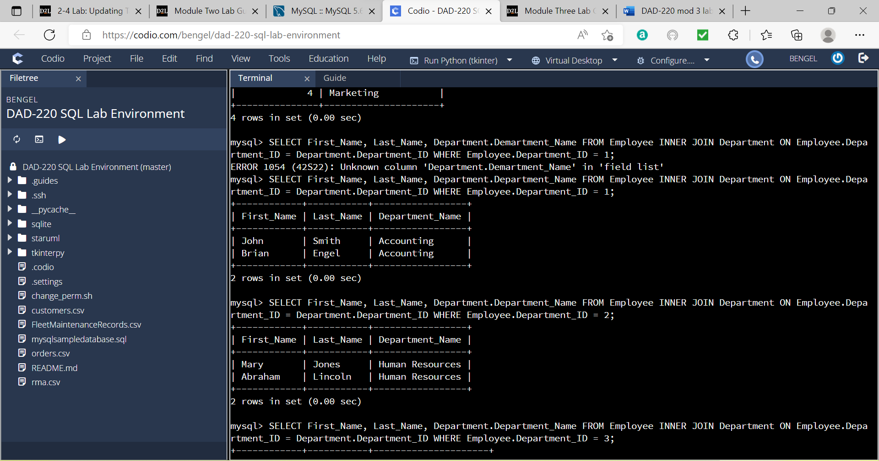

B. Department 2 – Human Resources

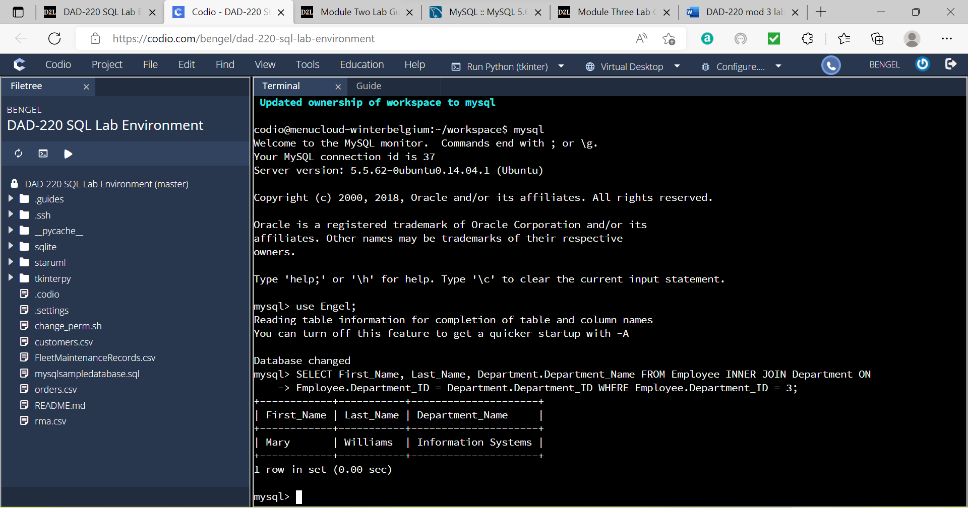

C. Department 3 – Information Systems

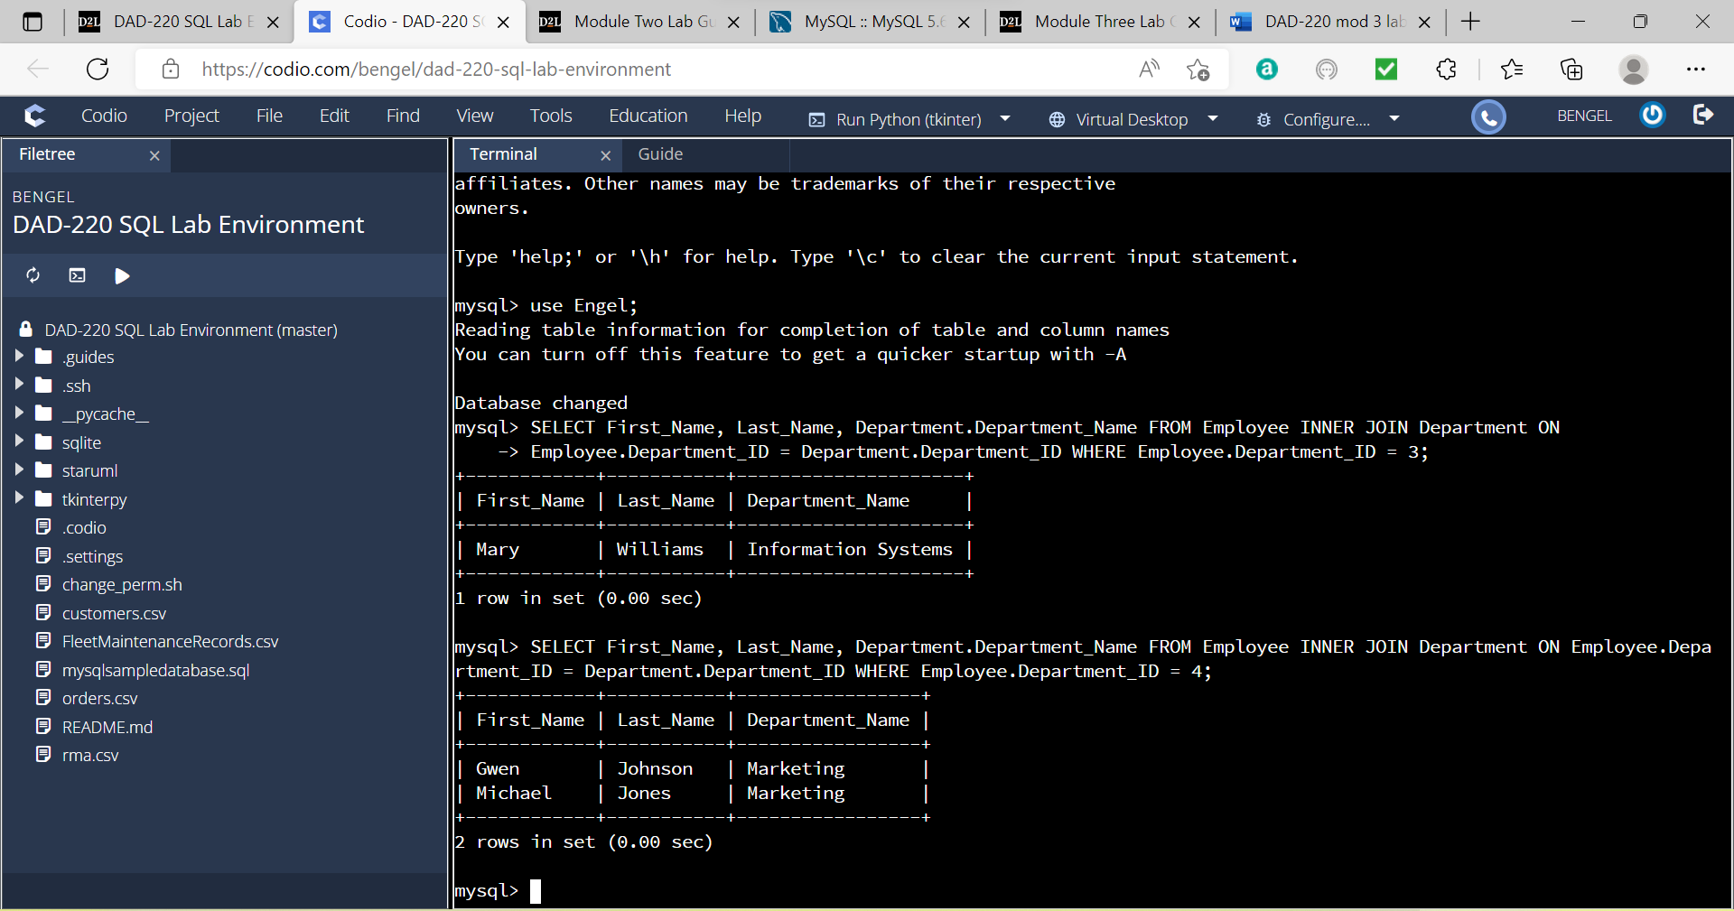

D. Department 4 – Marketing

1. Added 3 new employees to make a total of 10

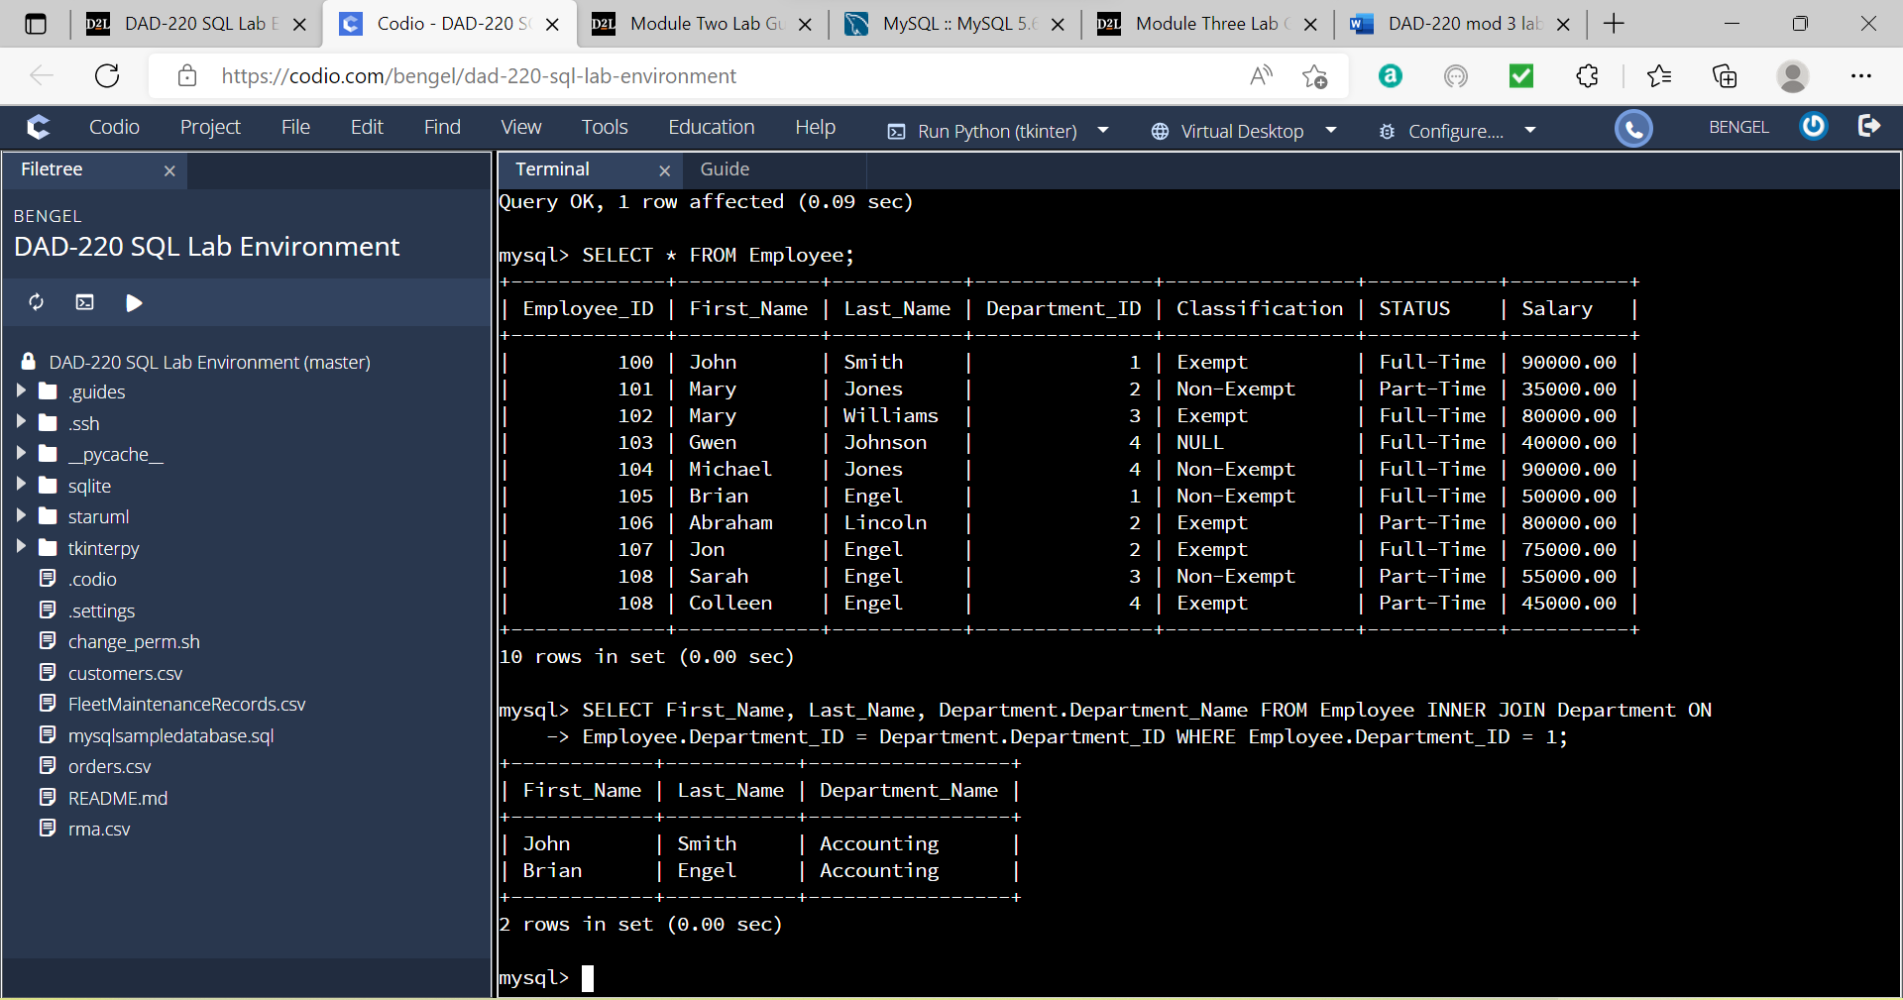

1. Preform joins between the Department and Employee tables and show results including new employees

A. Department 1 - Accounting

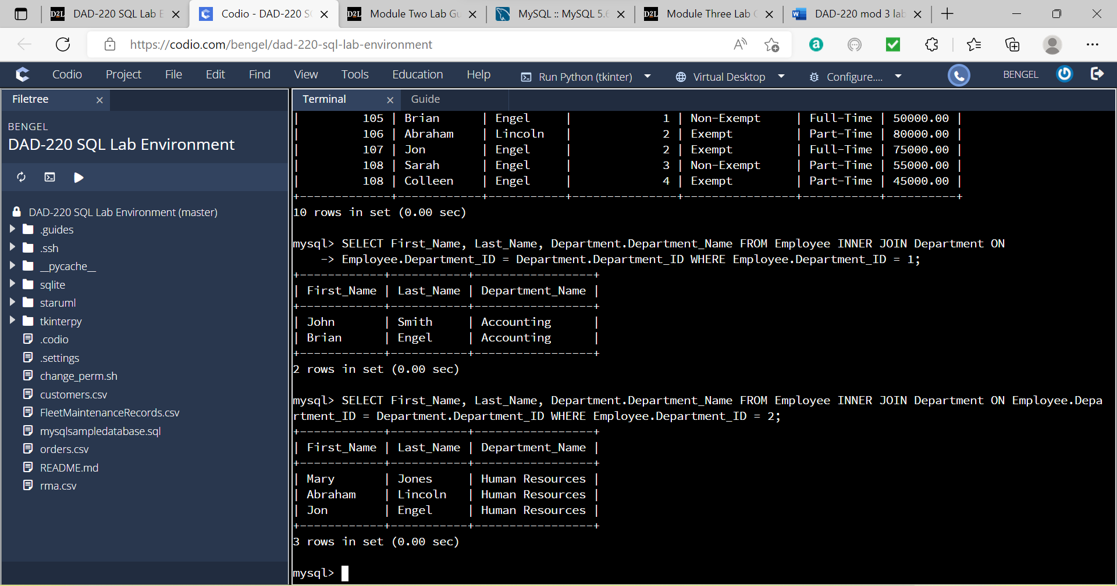

B. Department 2 – Human Resources

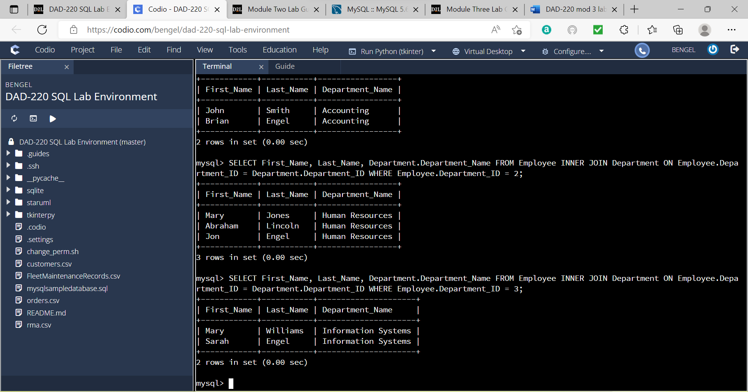

C. Department 3 – Information Systems

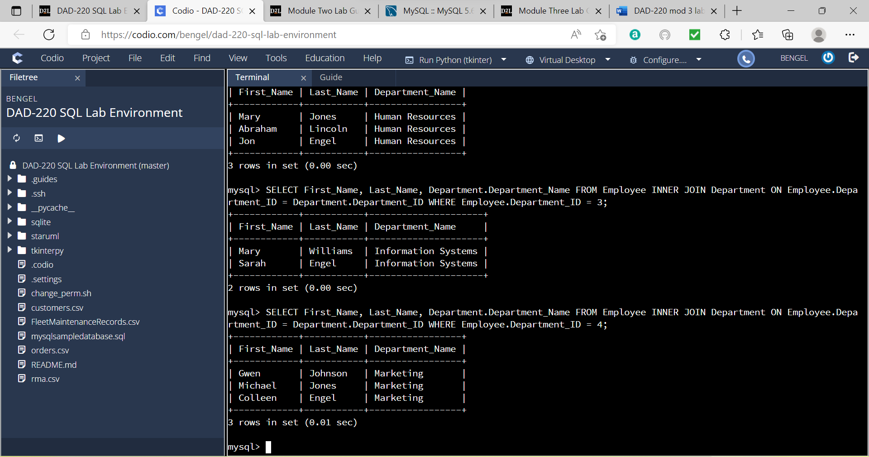

D. Department 4 – Marketing

6. Identify the resultant outputs

Accounting – 2 results

Human Resources – 3 results

Information Systems – 2 results

Marketing – 3 results

Total of 10

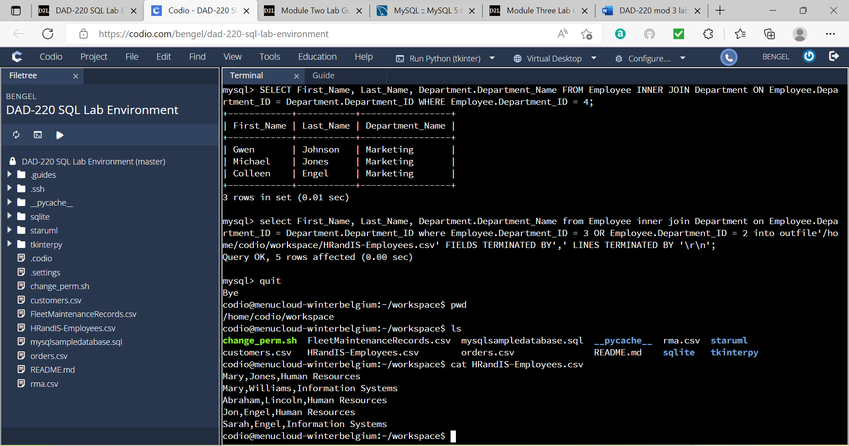

7. Create a CSV file and print to screen

8. Reflection

Process

1. The joins in this assignment where inner joins, which means they only join matching left and right table rows.

2. In the command: SELECT First_Name, Last_Name, Department.Department_Name FROM Employee INNER JOIN Department ON  
Employee.Department_ID = Department.Department_ID WHERE Employee.Department_ID = 1;

SELECT First_Name, Last_Name, Department.Department_Name are the fields to output

FROM Employee is the table the fields are selected from

INNER JOIN Department is the name of the new field after the join

ON Employee.Department_ID = Department.Department_ID are the fields to join and the condition for joining

WHERE Employee.Department_ID = 1; is the condition for only showing rows with Department_ID = 1

File creation and extraction

1. There are 5 records in the CSV file I created

3 from Human Resources

2 from Information Systems

2. select First_Name, Last_Name, Department.Department_Name from Employee inner join Department on Employee.Department_ID = Department.Department_ID where Employee.Department_ID = 3 OR Employee.Department_ID = 2 into outfile'/home/codio/workspace/HRandIS-Employees.csv' FIELDS TERMINATED BY',' LINES TERMINATED BY '\r\n';

(select First_Name, Last_Name, Department.Department_Name from Employee inner join Department on Employee.Department_ID = Department.Department_ID where Employee.Department_ID = 3 OR Employee.Department_ID = 2) this entire portion is the same as the join from above except it outputs Department_ID of 2 and 3

(into outfile'/home/codio/workspace/HRandIS-Employees.csv') into outfile tells where to put the file and everything in the ‘’ is the actual path and file name

(FIELDS TERMINATED BY',') lets the program know to put commas at the end of fields

(LINES TERMINATED BY '\r\n'); lets the program know to start a new line at the end of the line

Once you’re in the command line pwd prints the working directory

Ls lists all the files and directories in that directory

Cat is the command for printing the file to screen